|  |  |  |  |
| --- | --- | --- | --- |
| 2 | | 9,864 | |
| **NUMERO DE FRONTERAS** | | **ENERGIA AGREGADA** | |
|  | | | |
| 28,644,018 | 88 | | 1,050,111 |
| INGRESO 2019 | DÍAS CERTIFICADOS 2019 | | ENERGIA RESPALDADA 2019 |
|  | | | |
| 35,201,512 | 179 | | 1,308,379 |
| INGRESO 2020 | DÍAS CERTIFICADOS 2020 | | ENERGIA RESPALDADA 2020 |
|  | | | |
| 17,694,226 | 81 | | 792,152 |
| INGRESO 2021 | DÍAS CERTIFICADOS 2021 | | ENERGIA RESPALDADA 2021 |

**HISTORICO REINTEGRO DDV**

|  |  |  |  |
| --- | --- | --- | --- |
|  | **2019** | **2020** | **2021** |
| **ENE** | - | 7.84 | 0.07 |
| **FEB** | - | 10.29 | - |
| **MAR** | - | 3.43 | - |
| **ABR** | - | - | - |
| **MAY** | - | 2.59 | - |
| **JUN** | - | 4.59 | - |
| **JUL** | - | 1.56 | 4.3 |
| **AGO** | 2.98 | 1.4 | 5.21 |
| **SEP** | 9.07 | 0.85 | 4.11 |
| **OCT** | 9.91 | 1.11 | 4.0 |
| **NOV** | 6.68 | 0.76 | - |
| **DIC** | - | 0.77 | - |

**Los valores de la tabla están en millones de COP**

**REINTEGRO MECANISMO DDV OCTUBRE 2021**

|  |  |  |  |  |  |
| --- | --- | --- | --- | --- | --- |
| FECHA | TIPO DIA | CANTIDADES RESPALDO | PRECIO PONDERADO USD | TRM | PNETO |
| 2021-10-01 | Viernes | 9,863 | 5.98 | 3,784.44 | 199,995 |
| 2021-10-04 | Lunes | 9,863 | 5.98 | 3,784.44 | 199,995 |
| 2021-10-05 | Martes | 9,863 | 5.98 | 3,784.44 | 199,995 |
| 2021-10-06 | Miércoles | 9,863 | 5.98 | 3,784.44 | 199,995 |
| 2021-10-07 | Jueves | 9,863 | 5.98 | 3,784.44 | 199,995 |
| 2021-10-08 | Viernes | 9,863 | 5.98 | 3,784.44 | 199,995 |
| 2021-10-09 | Sábado | 9,863 | 5.98 | 3,784.44 | 199,995 |
| 2021-10-10 | Domingo - Festivo | 9,863 | 5.98 | 3,784.44 | 199,995 |
| 2021-10-11 | Lunes | 9,863 | 5.98 | 3,784.44 | 199,995 |
| 2021-10-18 | Domingo - Festivo | 9,863 | 5.98 | 3,784.44 | 199,995 |
| 2021-10-19 | Martes | 9,863 | 5.98 | 3,784.44 | 199,995 |
| 2021-10-20 | Miércoles | 9,863 | 5.98 | 3,784.44 | 199,995 |
| 2021-10-21 | Jueves | 9,863 | 5.98 | 3,784.44 | 199,995 |
| 2021-10-22 | Viernes | 9,863 | 5.98 | 3,784.44 | 199,995 |
| 2021-10-23 | Sábado | 9,863 | 5.98 | 3,784.44 | 199,995 |
| 2021-10-24 | Domingo - Festivo | 9,863 | 5.98 | 3,784.44 | 199,995 |
| 2021-10-25 | Lunes | 9,863 | 5.98 | 3,784.44 | 199,995 |
| 2021-10-26 | Martes | 9,863 | 5.98 | 3,784.44 | 199,995 |
| 2021-10-27 | Miércoles | 9,863 | 5.98 | 3,784.44 | 199,995 |
| 2021-10-28 | Jueves | 9,863 | 5.98 | 3,784.44 | 199,995 |

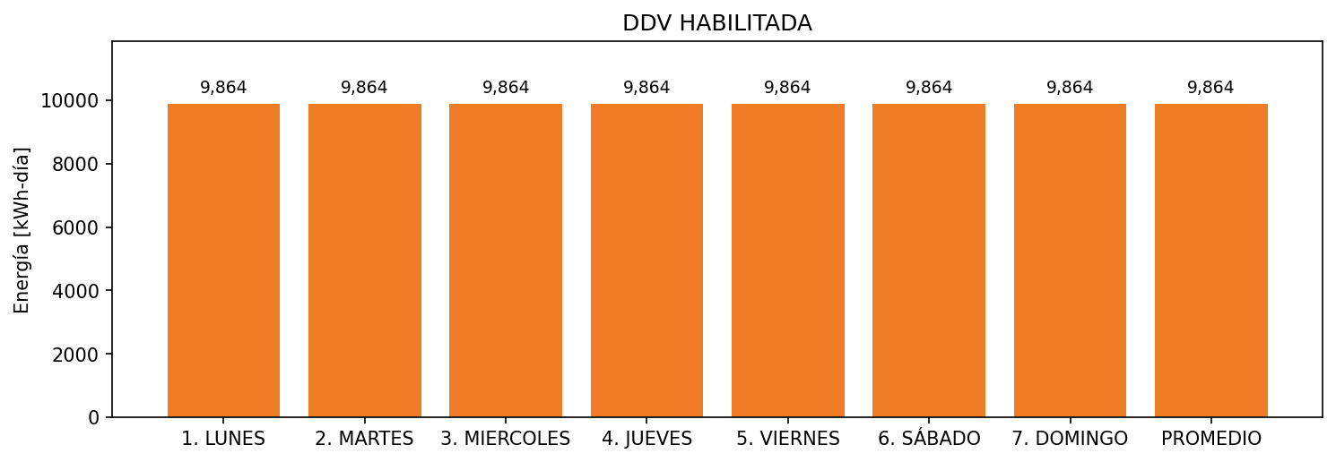

|  |  |  |  |  |  |  |  |  |  |
| --- | --- | --- | --- | --- | --- | --- | --- | --- | --- |
| **FRONTERA** | **COD SIC** | **FRT DDV** | **TIPO DDV** | **PROMEDIO** | **PRÓXIMA ACTUALIZACIÓN** | **MARGEN DE ERROR** | **ÚLTIMA PRUEBA DDV** | **DÍAS PARTICIPACIÓN** | **FECHA REFERENCIA PRÓXIMA PRUEBA DDV** |
| CENTRO COMERCIAL PORTAL DEL PRADO | Frt07297 | Frt41758 | GPE | 9,864 | 2026-04-15 | NO APLICA | 2021-06-30 | 80.0 | 2021-12-18 |
| CENTRO COMERCIAL PORTAL DEL PRADO | Frt07297 | Frt33667 | LBC | 0 | NO APLICA | NO APLICA | NO APLICA | 0.0 | 2022-03-17 |